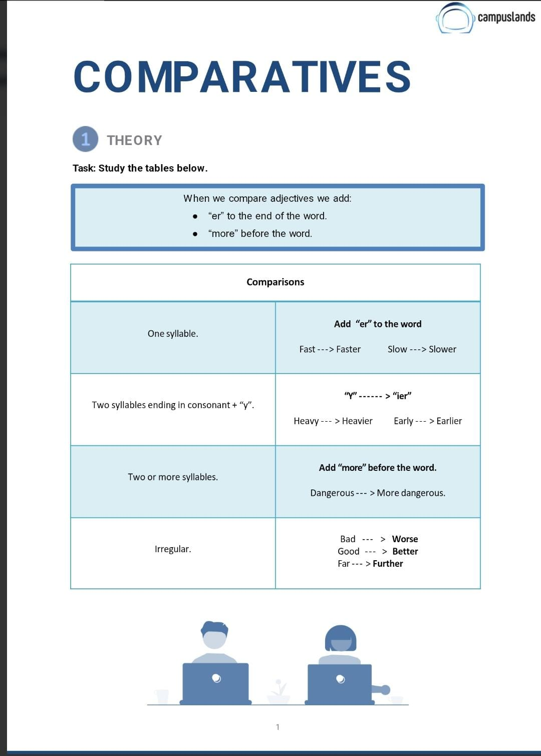

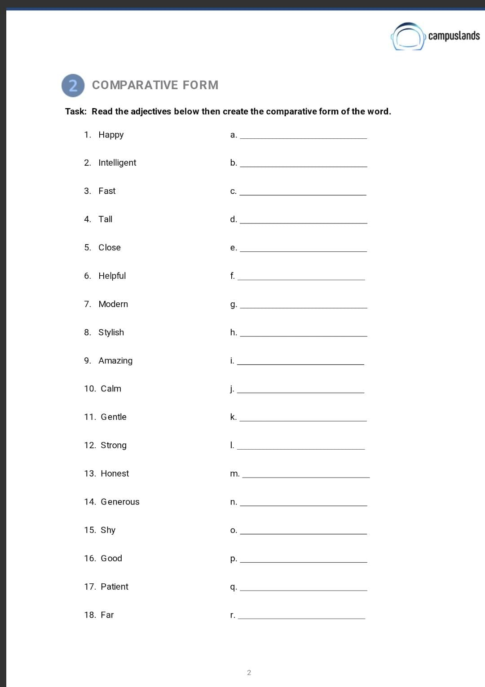
Happier
More Intelligent
Faster
Taller
Closer
More Helpful
More Modern
More Stylish
More Amazing
Calmer
Gentler
Stronger
More Honest
More Generous
Shyer
Better
More Patient
Further

Busier
More Modern
Dirtier
Cleaner
Richer
Further
Brighter
Healthier
More Comfortable
Safer
Happier
More Intelligent
Faster
Taller
Closer
More Helpful
More Modern
More Stylish
More Amazing
Calmer

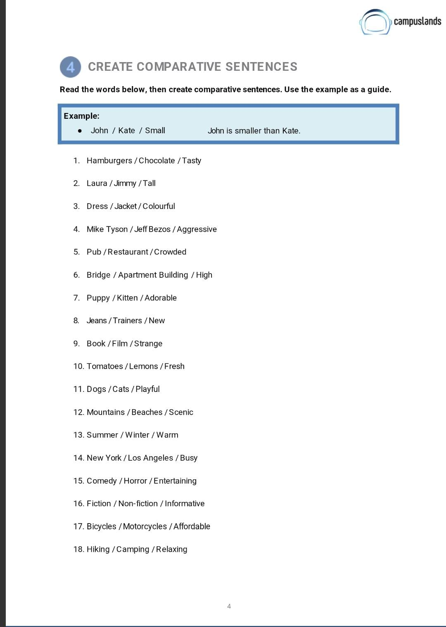
The hamburgers is tastier than Chocolate
Laura is taller tan Jimmy
The jacket is More Colourful than the dress
Mike Tyson is more Aggressive than Jeff Bezos
The Pub is More Crowded than the Restaurant
The Bridge is Higher than the Apartment Building
The Bridge is Higher than the Apartment Building
The Jeans are newer than the Trainers
The Book is More Stranger than the Film
The lemons are fresher than the tomatoes
Dogs are more playful than cats
Mountains are More Scenic than Beaches
Summer is warmer than winter
New York is busier than Los Angeles
New York is busier than Los Angeles
Non-fiction is More Informative than Fiction
Motorcyples are More Affordable than Bicycles
Camping is More Relaxing than Hiking

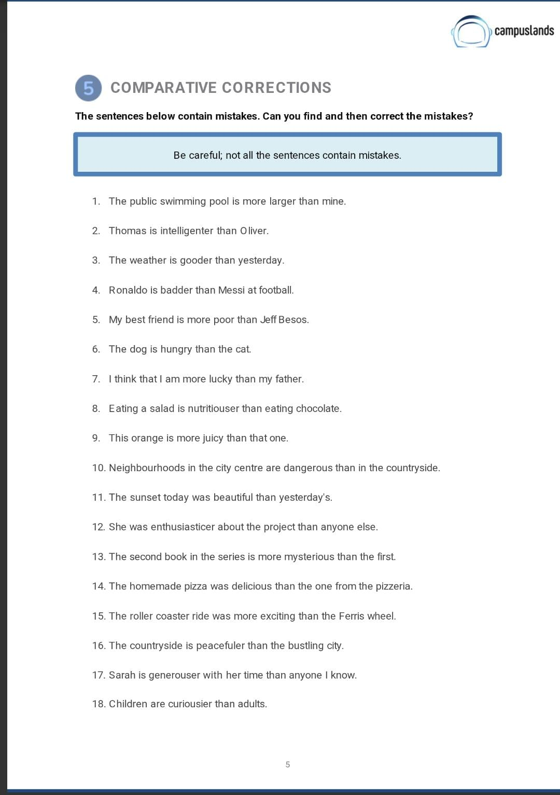
Thomas is More Intelligent than Oliver.
The weather is better than yesterday.
Messi is worse than Messi at football
My best friend is poorer than Jeff Besos
The dog is hungrier than the cat.
I think that I am luckier than my father.
I think that i am luckier than my father.
This Orange is juicier than that one.
Neighbourhoods in the city centre are more dangerous than in the countryside.
The sunset today was more beautiful than yesterday’s
She was more enthusiastic about the Project than anyone else.
The homemade pizza was more Delicious than the one from the pizzeria
The countryside is more peaceful than the bustling city.
Sarah is more generous with her time than anyone i know.
Children are more curious than adults.

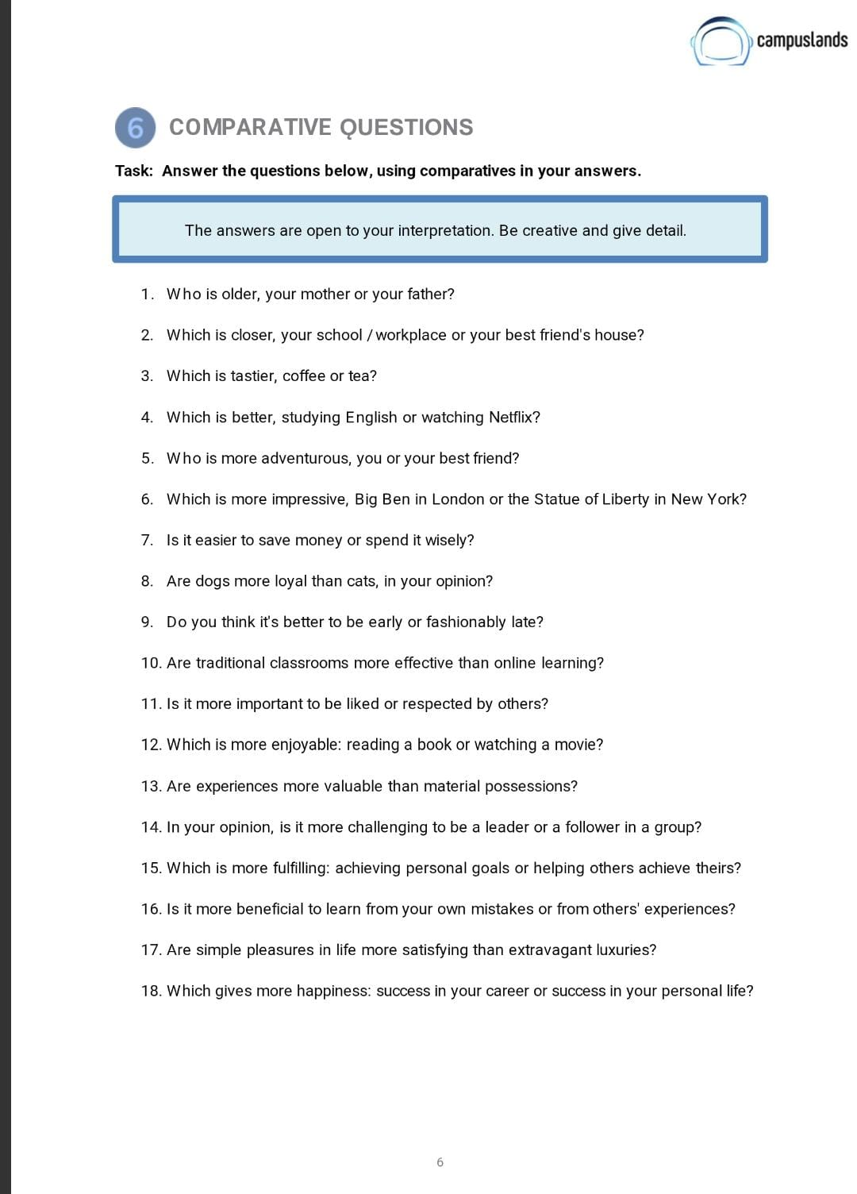

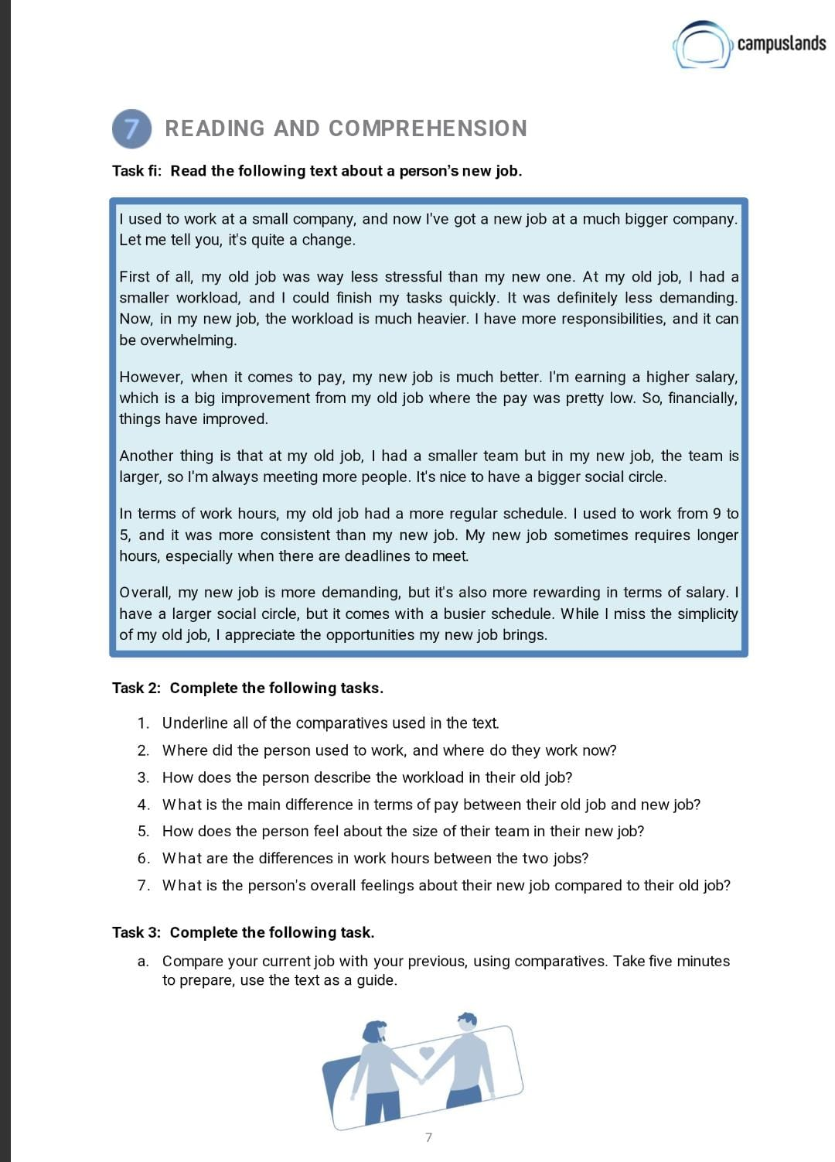

Comparative Questions.

Point 6.
- My father is actually older than my mother by a few years, which means he often tells stories from a slightly earlier era, while she's always been a bit more connected to contemporary trends.

- "My workplace is significantly closer than my best friend's house. I can walk to work in about 15 minutes, whereas getting to my friend's place requires a good 45-minute bus ride across town, making spontaneous visits less frequent.

- For me, coffee is definitely tastier than tea, especially a strong, aromatic espresso. While tea can be comforting, coffee offers a bolder flavor and a more immediate energy boost that I really appreciate in the mornings.

- Studying English is ultimately better than watching Netflix, even though Netflix might seem more entertaining in the short term. Learning a new skill like English provides long-term benefits for my career and personal growth, whereas Netflix is primarily for relaxation and entertainment.

- My best friend is undeniably more adventurous than I am. She's always eager to try new extreme sports or travel to remote places, while I tend to prefer more relaxed and predictable activities, although I do admire her courage.

- While both are iconic, I find the Statue of Liberty in New York more impressive than Big Ben. Its sheer scale and the powerful symbolism of freedom it represents, especially as a first sight for immigrants, give it a profound emotional impact that Big Ben, while grand, doesn't quite match for me.

- I think it's often easier to spend money than to save it wisely. Saving requires discipline and long-term planning, resisting immediate temptations. Spending, on the other hand, can be impulsive and the satisfaction is instant, even if it's not always a wise decision in the long run.

- In my opinion, dogs are generally more loyal than cats. Dogs often display an unwavering devotion and eagerness to please their owners, forming very strong, demonstrative bonds. Cats, while affectionate, tend to be more independent and express their loyalty in more subtle ways.

- I definitely think it's better to be early than fashionably late. Being early shows respect for others' time and allows you to prepare and settle in, whereas being late, even 'fashionably,' can be disruptive and inconsiderate, and it just creates unnecessary stress.

- For many, traditional classrooms are more effective than online learning, especially for younger students. The direct interaction with teachers and peers, the structured environment, and fewer distractions can lead to a deeper understanding and better retention, though online learning offers great flexibility.

- It is far more important to be respected than to be merely liked by others. Being liked can be superficial and fleeting, often based on popularity. Respect, however, is earned through integrity, competence, and consistent actions, leading to more meaningful and lasting relationships and influence.

- For me, reading a book is often more enjoyable than watching a movie. A book allows my imagination to run wild, creating detailed worlds and characters in my mind, which is a much more immersive and personal experience than simply observing someone else's interpretation on screen.

- Absolutely, experiences are infinitely more valuable than material possessions. Material things can break, lose value, or simply go out of fashion, but the memories, lessons, and personal growth gained from experiences, like travel or learning a new skill, last a lifetime and shape who you are.

- In my opinion, it is more challenging to be a leader than a follower in a group. Leaders bear the responsibility for decisions, motivate others, navigate conflicts, and inspire progress, which demands a complex set of skills and a lot of emotional intelligence. Followers, while important, generally have less pressure.

- While achieving personal goals is incredibly satisfying, I find that helping others achieve theirs is ultimately more fulfilling. Witnessing someone else's growth and success, knowing you played a part in it, creates a sense of profound shared accomplishment and positive impact that resonates deeply.

- It is more beneficial to learn from others' experiences than solely from your own mistakes. Learning from your own mistakes is crucial, but it can be painful and time-consuming. Observing and understanding the consequences of others' actions allows you to gain wisdom and avoid pitfalls without having to experience them firsthand, accelerating your learning curve.

- I believe simple pleasures in life are often more satisfying than extravagant luxuries. While luxuries might offer a fleeting thrill, the quiet joy of a warm cup of coffee in the morning, a walk in nature, or meaningful conversation provides a deeper, more consistent sense of contentment and well-being that truly enriches life.

- For long-term happiness, success in your personal life is undeniably more impactful than success in your career. A fulfilling personal life, built on strong relationships, good health, and personal growth, provides a foundational sense of peace and joy that even the most glittering career achievements cannot replicate if your personal life is in disarray.

Point 7.

Task 2: Complete the following tasks.

1. Underline all of the comparatives used in the text.
- "was less stressful than my new one"
- "is much heavier"
- "is much better"
- "is a big improvement from my old job"
- "the pay was pretty low" (Aquí "low" no es un comparativo per se, pero se usa en contraste con la mejora de sueldo, lo dejaremos como contexto)
- "had a smaller team than in my new job"
- "I'm always meeting more people"
- "had a more regular schedule"
- "is more demanding, but it's also more rewarding"
- "has a larger social circle"
- "comes with a busier schedule"

2. Where did the person used to work, and where do they work now?
- The person used to work at a small company.
- Now, they work at a much bigger company.

3. How does the person describe the workload in their old job?
- The person describes the workload in their old job as less demanding and could finish tasks quickly. They say the workload was much heavier in the new job.

4. What is the main difference in terms of pay between their old job and new job?
- The main difference is that the pay in the old job was pretty low, but in the new job, they are earning a higher salary, which is described as a big improvement.

5. How does the person feel about the size of their team in their new job?
- The person says they had a smaller team in their old job, but in the new job, the team is larger, so they are always meeting more people. They find it nice to have a bigger social circle as a result.

6. What are the differences in work hours between the two jobs?
- In terms of work hours, the old job had a more regular schedule (9 to 5) and was more consistent. The new job sometimes requires longer hours, especially when there are deadlines to meet.

7. What is the person's overall feelings about their new job compared to their old job?
- Overall, the person feels their new job is more demanding but also more rewarding in terms of salary and social opportunities. While they miss the simplicity of the old job, they appreciate the opportunities the new job brings. It's "much better" despite the increased workload.

Task 3: Complete the following task.

- Compare your current job with your previous, using comparatives. Take five minutes to prepare, use the text as a guide.

My Current Job (Junior Developer) vs. My Previous Job (Intern)
Moving from my Software Development Internship to my current role as a Junior Developer has been a big change.
My old internship was less stressful than my new job, with simpler tasks. Now, my workload is much heavier, and the problems are more complex.
Financially, my new job is much better. I'm earning a higher salary, a big improvement from the lower pay of my internship.
My old team was smaller, but now my team is much larger, and I'm meeting more people, which is great for my professional network.
The internship had a more flexible schedule. My current job sometimes requires longer hours and is less flexible.
Overall, my new job is more demanding but also more rewarding in terms of learning and salary. I appreciate the better opportunities it offers.

